# Recommended WiFi setup

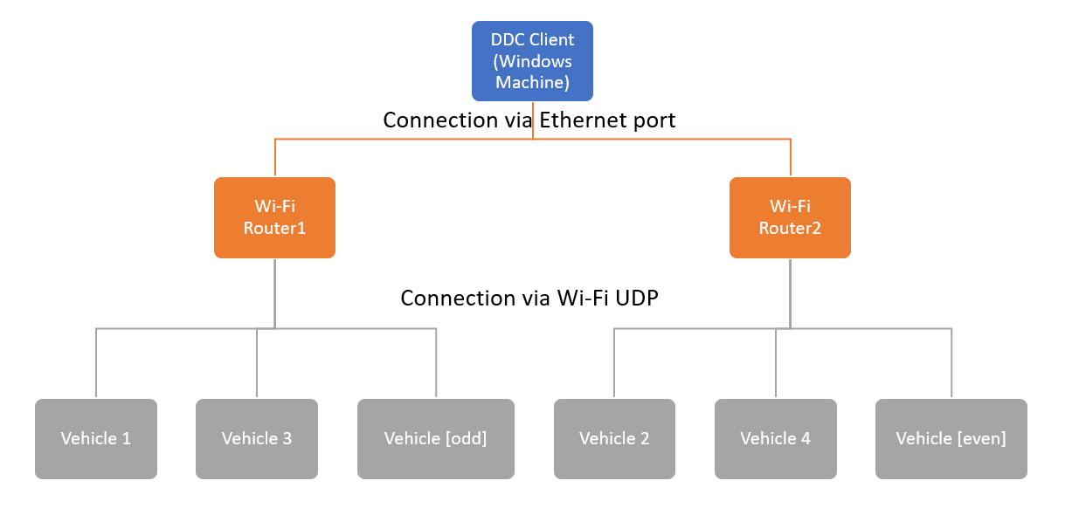

Wi-Fi routers are connected to each other ethernet port. Windows machine is connected to one of the routers ethernet port.

Routers, DDC Client and Vehicles are at the same sub net (as example 192.168.0.XXX). All devices have static IP address:

* Router1 – 192.168.0.1
* Router2 - 192.168.0.2
* DDC Client - 192.168.0.50
* Vehicle 1 – 192.168.0.101
* Vehicle 2 – 192.168.0.102
* Vehicle X – 192.168.0.[100+X]